Appetizers

Crispy French Fries 6
Cheese Fries 10
Chili Cheese Fries 14

Maine Baked Potato 6
Served with butter and sour cream.

Cheese and Pepperoni or Broccoli Baker 14
Served with butter and sour cream.

Chips and Dip ~ House-made kettle chips
served with garlic herb dip. 10

Hot Crisp Pizza Slices ~ Slice of pizza with 6
up to 2 of our toppings.

Pazzo Bread Sticks ~ Cheesy Pazzo sticks 10
served with red sauce.
Add Pesto 1
Finger Lickin’ Wings ~ Crispy chicken wings 23
with blue cheese and buffalo sauce.

Pork Dumplings ~ Deep fried pork stuffed 14
dumplings served with a ponzu dipping sauce

Baked Spinach & Artichoke Dip ~ 16
A creamy blend of spinach, artichoke and cheese
served with flat bread dippers

Mountain-Made
Soups & Stews
Add butter and baguette 5
Cup Bowl
Soup of the Day ~ 7.75 10

Maine Seafood Chowder ~ 9.75 13

Hot Mountain Chili ~ 7.75 10
Add salsa, sour cream and veggies 13
Ask about our gluten-free options
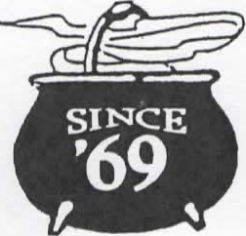
Great Plates
All Great Plates served with French fries.

The Bag Burger ~ Charbroiled ground beef with melted cheese, lettuce, tomato, onion, a toasted bun and House dressing. 20
The Gucci ~ Local favorite with pepperoni 22

Super Quad Tender ~ For our young 20
gourmets – light oil fried chicken tenders.

Blue Steele ~ Gorgonzola spread and 22
caramelized onions

The Dior ~ Garlic herb cheeseburger. 22

Bag Broiler ~ Charbroiled juicy chicken 20
breast filet on a toasted bun.
Chicken Burger ~ The other burger 19
alternative – tender fried chicken on a
toasted bun with cheese.

Pulled Pork Rachel ~ Slow roasted pork 20
Shoulder, BBQ, coleslaw on a toasted bun.

Fish and Chips ~ An old English tradition. 20
Crispy flaky cod fillet with coleslaw.

Fish Switch ~ The burger alternative. Flaky 20
cod fillet on a toasted bun with cheese.

Quad Melt ~ A blend of cheese melted on a 22
mound of roast beef on a toasted bun.

Veggie Burger ~ red quinoa and veggie mix 24
made in The Forks of Maine with cheese on a
toasted bun.

Dixie Chicken ~ Chicken tenders, swiss, 20
pickles, BBQ sauce on a toasted bun.

Salads
Bag Salad ~ Mixed greens with seasonal 15
vegetables, pepperoncini and marinated
black olives. Bag Caesar ~ with croutons, parmesan and 20
Classic dressing.
Spinach Salad ~ baby spinach, grape 20 tomatos, red pepper, mushrooms, Feta, Kalamata
olives and balsamic dressing.
Chefs Turkey Salad ~ 22 Turkey, swiss and a hard-boiled egg on a
loaded salad.
Cobb Salad ~ Grilled Chicken, avocado, 26 hard-boiled egg, gorgonzola crumbles, crispy
bacon on a loaded salad served with balsamic.
King’s Bag Salad ~ Mixed greens, seasonal 24
vegetables, turkey, parmesan, marinated
olives and croutons
Add Grilled or Crispy Chicken 7
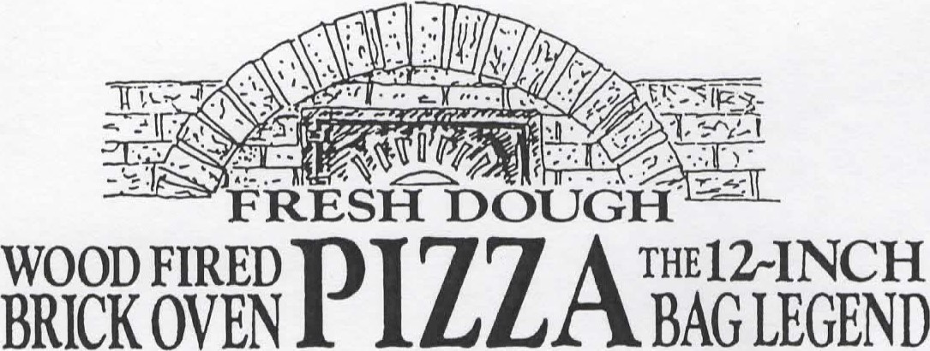
Made with the freshest produce available and baked to perfection.
1.The Bag’s Mountainous Pepperoni 19
2.Pepperoni and Fire Roasted Peppers 21
3. Hot Hawaiian 22
Ham, Bacon, Pineapple, jalapenos and Siracha
4.Greek Goddess 22
White sauce, spinach, bacon, feta,
Kalamata olives
5.Tuscan Rustico 22
Artichoke, roasted peppers, tomato
6.Chicken Alfredo 22
Broccoli, bacon
7. Veggie Deluxe 23
A pretty garden pie with caramelized onions
8.The Bag Monster ~a perfect pizza~ 24
9.Plain Cheese Pizza 16
10.Mediterranean 22
Marinated olives, roasted peppers, feta, bacon
11.Barbegue Chicken 22
Barbeque sauce, crispy chicken, red onion, bacon 12.Shredders Extreme Experience 22
Crispy chicken, bacon, caramelized onion, Monterey Jack
13.Margherita Pizza 24
Roma tomato, fresh basil, fresh mozzarella, garlic and balsamic drizzle
14.The Bag’s Bag Burger Pizza 24
House, burger, tomato, onion, American cheese
Add any one topping 4

Mountainous Sandwiches
Available 11:00am-5:00pm
All sandwiches are spread with house dressing, unless otherwise noted, and served with house-made kettle chips.
Add Fries for 3

Bread choices-
Multigrain, Marbled Rye, Sourdough, Wrap.

The Quad Lift ~ Smoked turkey breast, 22
fancy ham, salami, swiss, and crisp vegetables.

Roast Beef ~ Thinly sliced prime roast beef. 20

Reuben ~ Pastrami, swiss and sauerkraut. 20

Pastrami ~ Hot pastrami 19

Salami ~ Genoa salami and swiss 18

Ham and Swiss ~ Fancy ham and swiss 18

Turkey and Swiss ~ Smoked turkey, swiss, 20
Lettuce, tomato and mayo.

Cranberry Walnut Chicken Salad 21 With lettuce and tomato.

The Gregarious Garden Melt 20
Crisp pepperoni, salami, roasted peppers, marinated olives, mushrooms, swiss and Monterey jack on a baguette served with fries.
Also available veggie style.

P.L.T ~ a local favorite. Crisp pepperoni strips, 20
lettuce, tomato and mayo.

Garden ~ Lettuce, tomato, swiss, mushrooms, 19
Onions and green peppers.

Ask About Our Desserts
Too full now? Take it for later. Michele’s house-made desserts are not to be missed. Ask your server what she has created today.

#bagburger
207-237-2451 www.bagandkettle.com

Warning: Consuming raw or undercooked meats, eggs, shellfish or poultry may increase your risk of foodborne illness, especially if you have certain medical conditions.

