Appetizers

Crispy French Fries 6
Cheese Fries 8
Chili Cheese Fries 10.50

Mexican Potato Skins ~ Baked potato skins 12
Topped with melted cheese and bacon served with
sour cream, salsa and jalapenos.

Maine Baked Potato 6
Served with butter and sour cream.

Cheese and Pepperoni or Broccoli Baker 7.50
Served with butter and sour cream.

Chips and Dip ~ House-made kettle chips
served with garlic herb dip. 9

Hot Crisp Pizza Slices ~ Slice of pizza with 6
up to 2 of our toppings.

Pazzo Bread Sticks ~ Cheesy Pazzo sticks 8
served with red sauce.
Add Pesto 1
Finger Lickin’ Wings ~ Crispy chicken wings 20
with blue cheese and buffalo sauce.

Pork Dumplings ~ Deep fried pork stuffed 12
dumplings served with a ponzu dipping sauce

Baked Spinach & Artichoke Dip ~ 16
A creamy blend of spinach, artichoke and cheese
served with flat bread dippers

Mountain-Made
Soups & Stews
Add butter and baguette 5
Cup Bowl
Soup of the Day ~ 6.75 9.00

Maine Seafood Chowder ~ 7.25 9.50

Hot Mountain Chili ~ 6.75 9.00
Salsa, sour cream and veggies 11.75
Ask about our gluten-free options
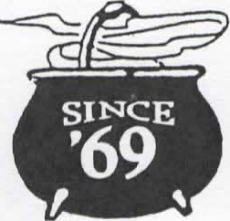
Great Plates
All Great Plates served with French fries.

The Bag Burger ~ Charbroiled ground beef with melted cheese, lettuce, tomato, onion, a toasted bun and House dressing. 18
The Gucci ~ Local favorite with pepperoni 20

Super Quad Tender ~ For our young 18
gourmets – light oil fried chicken tenders.

Blue Steele ~ Gorgonzola spread and 20
caramelized onions

The Dior ~ Garlic herb cheeseburger. 20

Bag Broiler ~ Charbroiled juicy chicken 18
breast filet on a toasted bun.
Chicken Burger ~ The other burger 17
alternative – tender fried chicken on a
toasted bun with cheese.

Pulled Pork Rachel ~ Slow roasted pork 18
shoulder, BBQ, coleslaw on a toasted bun.

Fish and Chips ~ An old English tradition. 18
Crispy flaky cod fillet with coleslaw.

Fish Switch ~ The burger alternative. Flaky 18
cod fillet on a toasted bun with cheese.

Quad Melt ~ A Blend of cheese melted on a 20
mound of roast beef on a toasted bun.

Veggie Burger ~ red quinoa and veggie mix 22
made in the forks of Maine with cheese on a
toasted bun.

Dixie Chicken ~ Chicken tenders, swiss, 18
pickles, BBQ sauce on a toasted bun.

Salads
Bag Salad ~ Mixed greens with seasonal 12
vegetables, pepperoncini and marinated
black olives.
Bag Caesar ~ with croutons, parmesan and 16
Classic dressing.
Chefs Turkey Salad ~ 18
Turkey, swiss and a hard-boiled egg on a
loaded salad.

Cobb Salad 20
Grilled Chicken, avocado, hard-boiled egg,
gorgonzola crumbles, crispy bacon on a loaded
salad served with balsamic.

King’s Bag Salad ~ Mixed greens, seasonal 20
Vegetables, turkey, parmesan, marinated
olives and croutons
Add Grilled or Crispy Chicken 6
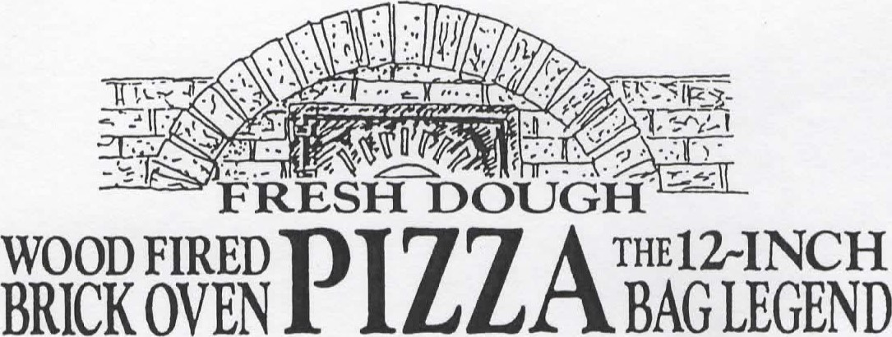
Made with the freshest produce available and baked to perfection.
1.The Bag’s Mountainous Pepperoni 17
2.Pepperoni and Fire Roasted Peppers 19
3. Hot Hawaiian 20
Ham, Bacon, Pineapple, jalapenos and Siracha
4.Greek Goddess 20
White sauce, spinach, bacon, feta,
Kalamata olives
5.Tuscan Rustico 20
Artichoke, roasted peppers, tomato
6.Chicken Alfredo 20
Broccoli, bacon
7. Veggie Deluxe 21
A pretty garden pie with caramelized onions
8.The Bag Monster ~a perfect pizza~ 22
9.Plain Cheese Pizza 14
10.Mediterranean 20
Marinated olives, roasted peppers, feta, bacon
11.Barbegue Chicken 20
Barbeque sauce, crispy chicken, red onion, bacon 12.Shredders Extreme Experience 20
Crispy chicken, bacon, caramelized onion, Monterey Jack
13.Margherita Pizza 22
Roma tomato, fresh basil, fresh mozzarella, garlic and balsamic drizzle
14.The Bag’s Bag Burger Pizza 22
House, burger, tomato, onion, American cheese
Add any one topping 3

Mountainous Sandwiches
Available 11:00am-5:00pm
All sandwiches are spread with house dressing, unless otherwise noted, and served with house-made kettle chips.
Add Fries for 3

Bread choices-
Multigrain, Marbled Rye, Sourdough, Wrap.

The Quad Lift ~ Smoked turkey breast, 18
fancy ham, salami, swiss, and crisp vegetables.

Roast Beef ~ Thinly sliced prime roast beef. 20

Reuben ~ Pastrami, swiss and sauerkraut. 18

Pastrami ~ Hot pastrami 17

Salami ~ Genoa salami and swiss 16

Ham and Swiss ~ Fancy ham and swiss 16

Turkey and Swiss ~ Smoked turkey, swiss, 16
Lettuce, tomato and mayo.

Cranberry Walnut Chicken Salad 16
With lettuce and tomato.

The Gregarious Garden Melt 18
Crisp pepperoni, salami, roasted peppers, marinated olives, mushrooms, swiss and Monterey jack on a baguette served with fries.
Also available veggie style.

P.L.T ~ a local favorite. Crisp pepperoni strips, 16
lettuce, tomato and mayo.

Garden ~ Lettuce, tomato, swiss, mushrooms, 16
Onions and green peppers.

Ask About Our Desserts
Too full now? Take it for later. Michele’s house-made desserts are not to be missed. Ask your server what she has created today.

#bagburger
207-237-2451 www.bagandkettle.com

Warning: Consuming raw or undercooked meats, eggs, shellfish or poultry may increase your risk of foodborne illness, especially if you have certain medical conditions.

